78

Community Inventory for Service Learning
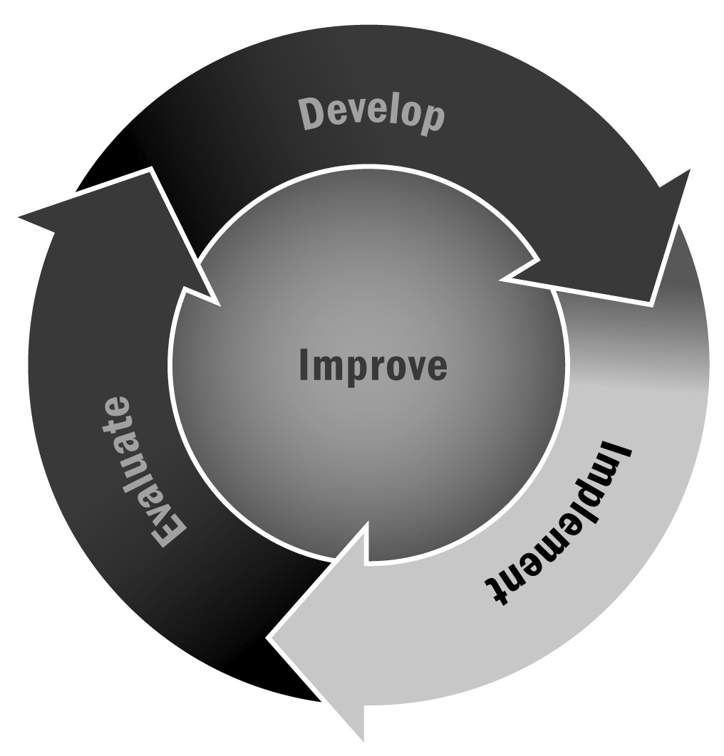
In Chapter 4, you learned that service learning can help improve youth academic success, develop a sense of civic responsibility, and support connections to the community. Identifying the needs in your community can help you develop service learning activities that are beneficial for youth while also providing an important service to the community.
Directions: Youth, in partnership with adult advisors, should read the following list of topic areas and put a check next to the ones they believe are priorities in your community or in your school. Then have them circle the three issues they believe are most important or are of most interest and list them below. Finally, youth and their advisors should brainstorm ideas for projects or community partners based on these needs.

Cultural
❒ | Cross-cultural communication | ❒ | Other cultural issues
❒ | Supporting recognition of cultural connections in the community

Education
❒ | High-quality early childhood education | ❒ | Ninth-grade transition
❒ | Afterschool and expanded learning programming | ❒ | Other educational issues
❒ | High school completion

Employment
❒ | Youth employment | ❒ | Job training
❒ | Building the local workforce | ❒ | Other employment issues

Environment
❒ | Recycling | ❒ | Community gardening
❒ | Parks/green space | ❒ | Other environmental issues
❒ | Neighborhood beautification

Health
❒ | Access to health care | ❒ | Nutrition
❒ | Prenatal care | ❒ | Other health issues
❒ | Substance abuse prevention

Recreation
❒ | Access to open space | ❒ | Sports and recreation opportunities for youth
❒ | Fitness for adults | ❒ | Other recreation issues

Safety
❒ | Access to safe facilities | ❒ | Streetlights
❒ | Public transportation | ❒ | Other safety issues
❒ | Community policing

Social Services
❒ | High-quality child care | ❒ | Support for families living in poverty
❒ | High-quality senior care and services | ❒ | Other social services issues

Top Three Issues

Issue/Topic | Possible Program Partners | Possible Project Ideas
1.
2.
3.

